INDEXU 7
How to set maximum character limit for custom field

By Dody Rachmat W. (dodyrw@gmail.com)
August 26, 2011

In this tutorial we are going to set maximum number of character for description field. We will use “CUSTOM” validation.

- Go to Admin Panel > Custom Fields > Manage Link Fields > description [edit]
- Scroll down until you see form for VALIDATION: Custom. This validation type allow you to enter custom php code to validate the entry. Here we will use php function called strlen to check the number of characters.
- Set :
- Enable = Yes
- Error message = Maximum character for description is 200
- PHP codes =
strlen( <FORM.description> ) <= 200
/*
when condition = false, it trigger the error message
in above example, condition = false if number of characters is more than 200
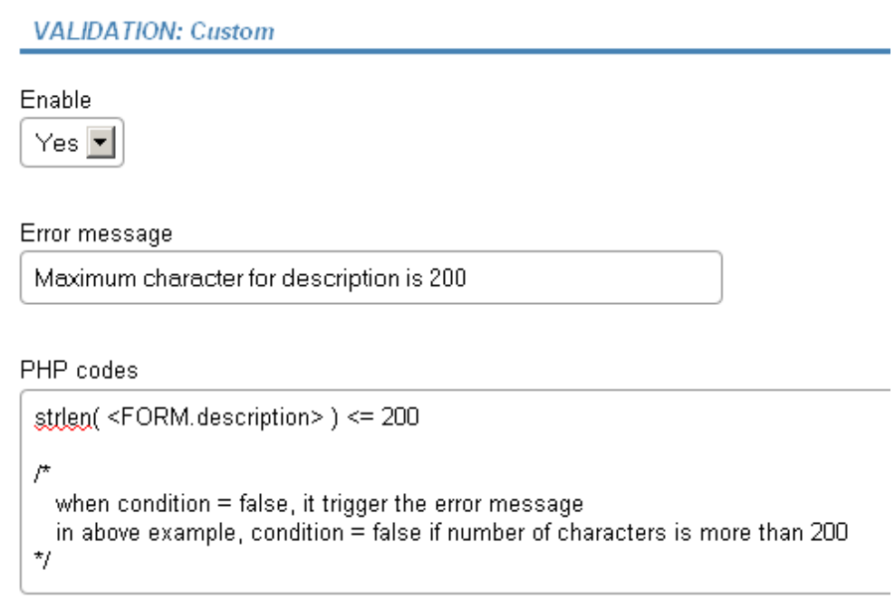
*/
Notice this code part : <FORM.description>
The description in that part is referring to the field name. In this is the field name is description.

